Here are a few graphs and tables to update the last bit of sampling.

Simple table defining strata and information on total transect length sampled, number of collapsed transects, mean length of collapsed transect. A collapsed transect occurs when multiple transects are measured on one reef in a given sampling trip. Those transects are then summed by length and counts and considered one transect.

|  |  |  |  |  |  |
| --- | --- | --- | --- | --- | --- |
| Fishing (Y/N) | Rock (LG/SM/NA) | Strata | Total tran sampled (m) | N collapsed transects completed | Mean collapsed transect length m |
| N | LG | N_LG | 519.01 | 7 | 74.14 |
| N | NA | N_NA | 503.88 | 16 | 31.49 |
| N | SM | N_SM | 113.35 | 2 | 56.67 |
| Y | NA | Y_NA | 271.5 | 10 | 27.15 |
| Y | SM | Y_SM | 216.13 | 2 | 108.06 |

Estimated number of collapsed transects required for given power

|  |  |  |  |  |  |
| --- | --- | --- | --- | --- | --- |
|  | N_LG | N_NA | N_SM | Y_NA | Y_SM |
| N_LG |  |  |  |  |  |
| N_NA | 8 |  |  |  |  |
| N_SM | 4 | 19 |  |  |  |
| Y_NA | 18 | 404 | 72 |  |  |
| Y_SM | 2 | 2 | 2 | 2 |  |

The best way to interpret this is that it is really hard to detect a difference between Y_NA and N_NA. This is because the variance is so high (see below). For Y_SM don’t be misled, there have been few samples (2 collapsed) and the variance is less than the mean. Maybe that will hold and that makes it easier to detect differences. Maybe it won’t hold. Y_SM needs more sampling.

A graph of density by station color/shape coded by strata. I think this is what Peter was sort of asking for.

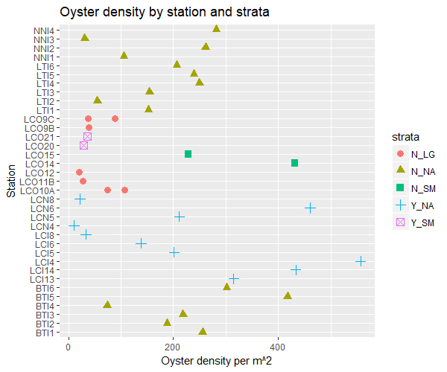

This is important because it shows the “spread” within each strata (shape and color). So for Y_NA the density estimates are highly variable, that’s why there is a huge spread. Compare that to Y_SM (but note only 2 samples taken).

Below is just a histogram of density by collapsed transect

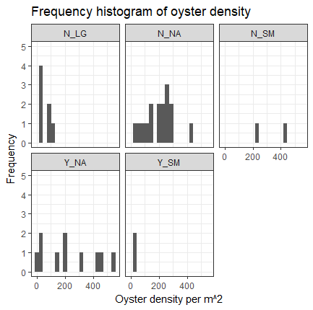

Simple table of oyster density summary stats by strata

|  |  |  |  |
| --- | --- | --- | --- |
| density/m2 |  | mean | variance |
|  | N_LG | 56 | 1127 |
|  | N_NA | 199 | 10291 |
|  | N_SM | 330 | 20626 |
|  | Y_NA | 238 | 38619 |
|  | Y_SM | 33 | 27 |